MODERN CLASSROOMS, MODERN EDUCATION
SCOALA GIMNAZIALA 'IONEL TEODOREANU', IASI
TEACHER: MIRELA BUZILA
lesson plan:  SOMNOROASE PASARELE/ DROWSY BIRDS |  | resources:
level: lower secondary |  | lesson number: 2
Age of students: 12
UNIT: |  | SUBUNIT:
GENERAL GOALS:
Students will know more about Romanian culture and will enhance their vocabulary for poem discussion.

VOCABULARY covered during the lesson:
words related to sleep, night and nature.

REQUIRED PRE KNOWLEDGE:
general knowledge of literature terms

SPECIFIC OBJECTIVES (specify skills / information that will be learned):
Students practice speaking skills – talking about a poem.

MATERIALS NEEDED:  - blackboard  - IWB + projector  - computers  - paper sheets | OTHER MATERIALS NEEDED:  - PowerPoint presentation ‘DROWSY BIRDS’  - Kahoot quiz  https://create.kahoot.it/k/71dd3550-5fe4-4a97-a18c-4ec5e2fbe05e  - crosswords

TEACHER | STUDENTS
LEAD IN: 5’  What is your favourite poem/ poet? Can you recite 4 lines?  LISTENING AND SPEAKING: 15’  The teacher use a PowerPoint presentation and asks questions, then checks the answers and corrects possible mistakes.  AFTER-LISTENING  10’  The teacher uses the Kahoot quiz to check understanding and learning of the topic.  The teacher corrects possible mistakes.  CROSSWORD: 8’  The teacher gives crosswords (Annex 1)  CREATIVE TASK: 10’  The teacher offers papers.  The teacher reinforces the proper way to write a stanza which would be similar to the other 4.  CLOSURE: 2’  Evaluation, feedback. | Students volunteer to present a poem and/or tell us a few lines from it.  Students watch the PPT and answer the questions. Students answer what is the poem about, what is the theme of it, …  Students actively participate and compete in pairs.  (Everybody is a winner).  Students solve the crosswords.  Students draw the image of the poem – or what did they get from the poem, using whatever technique they prefer.  Advanced students/ groups of students can write a new stanza for the poem. (3 verses of 8 syllables and one of four = a formula)

Annex 1
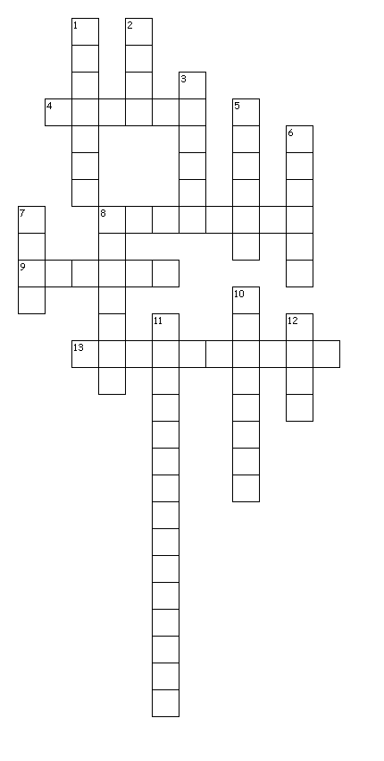

Across
4. / strophe
8. / A Romanian poet
9. / another word for source
13. / the action of repeating something that has already been said or written

Down
1. / his age when his first poem was published
2. / white queen of water
3. / ground used for growing flowers, fruit, or vegetables
5. / sleepy
6. / one of Eminescu’s favourite themes
7. / a structure made by a bird for laying eggs and sheltering its young
8. / adjective expressing a quality characteristic of the person or thing
10. / a figure of speech in which a word or phrase is applied to an object or action to which it is not literally applicable
11. / the attribution of a personal nature or human characteristics to something nonhuman
12. / queen of the night

