Odysseus Elytis

Biography

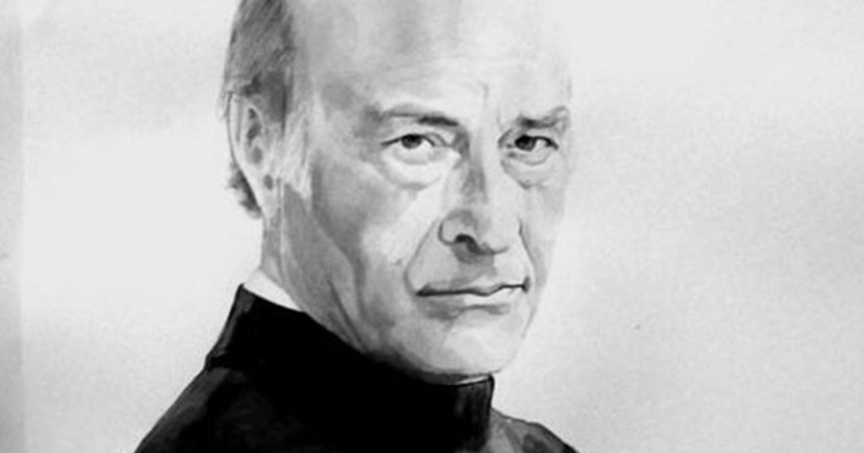
Odysseus Elytis (his real name was Odysseus Alepoudelis) was born in the city of Heraklion, on the island of Crete, on 2 November 1911. His family later moved to Athens, where the poet finished high school and went to law school at the University of Athens. His first appearance as a poet in 1935 through the magazine “Nea Grammata” (“New Culture”). It was considered an important event because of the new style of his poetry.
During the Second World War (1939 – 1945) Elytis served his military service on the first-line of the battlefields.
During the years 1948-1952 and 1969-1972 he lived in Paris. There, he listened to literature lessons in Sorbonne and got to know some of the most famous artists in the world.
He was invited to travel through the U.S.A. in 1961, through the Soviet Union in 1963 and Bulgaria in 1965.
Odysseus Elytis had been making plans to travel abroad when he died in Athens on 18 March 1996, at the age of 84.
Elytis' poetry was greatly influenced by the surrealist movement (see the hyperlink below), an art movement that appeared in France and influenced artists around the world (mainly writers and painters)

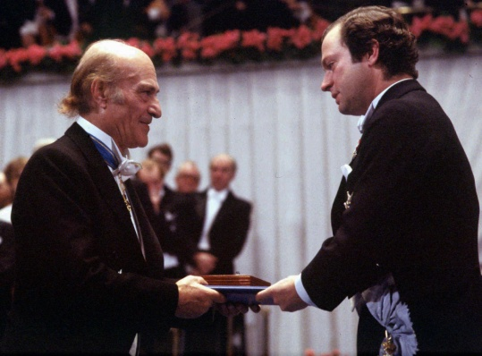
Odysseus Elytis was awarded the Nobel Prize for literature in 1979. The academy declared in its presentation that “his poetry describes modern man's struggle for freedom and creativeness. . . . Elytis' poetry is not only very personal but also represents the traditions of the Greek people.” He borrowed certain elements from Ancient Greece and Byzantium but devoted himself exclusively to today's Hellenism, of which he attempted to reconstruct a modernist mythology for the institutions.

Except for creating poetry he translated poetry and theatre. He also made a series of collage pictures and paintings.

Some of Elytis' poetry

Orientations (1940)

To Axion Esti—It Is Worthy (1959)

The Light Tree And The Fourteenth Beauty (1972)

The Trills of Love (1973)

The Monogram (1972)

Maria Nefeli ( 1978)

Diary of an Invisible April (1984)

The Little Mariner (1988)

West of Sadness (1995)

Surrealism easily explained

General Overview
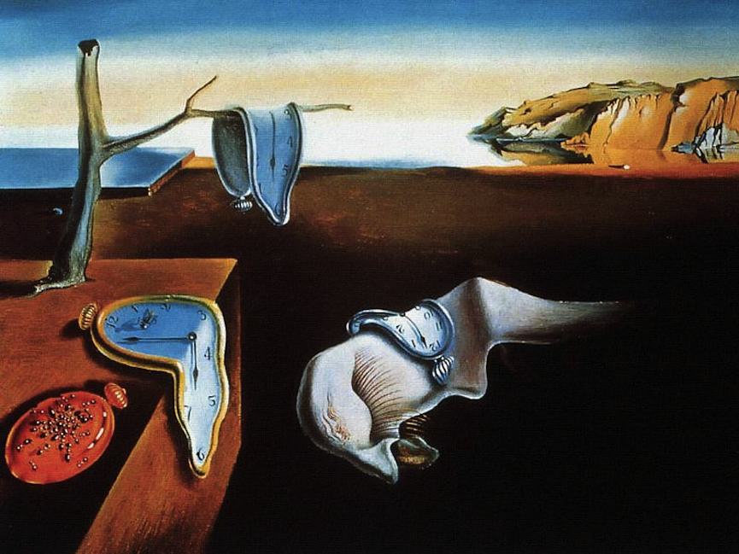
Surrealism began as a philosophical movement that said the way to find truth in the world was through the subconscious mind and dreams, rather than through logical thought. The movement included many artists, poets, and writers who expressed their theories in their work. The Surrealist movement was started by French Poet Andre Breton who wrote The Surrealist Manifesto in 1924.

When was the Surrealism movement?
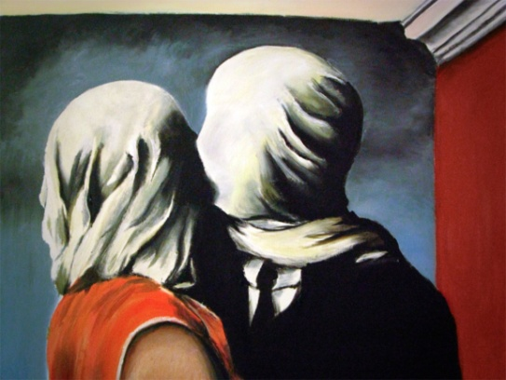
The movement began in the mid-1920s in France and was born out of an earlier movement called Dadaism from Switzerland. It reached its peak in the 1930s.

What are the characteristics of Surrealism?

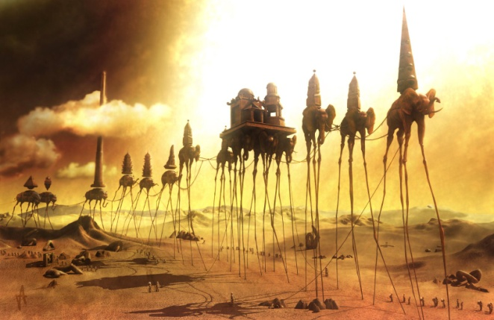
Surrealism means "above realism". Surrealism images explored the subconscious areas of the mind. The artwork often made little sense as it was usually trying to describe a dream or random thoughts.

For more informations visit :

https://www.ducksters.com/history/art/surrealism.php

Video

What has a lobster got in common with a telephone? Find out here!

https://www.tate.org.uk/kids/explore/what-is/surrealism

